**Estimating Total Change from Rates of Change  
Homework**

*In your answers to the following questions, discuss your reasoning as you answer the questions. These explanations are bound to require both written words, and some carefully chosen diagrams. If you do calculations using Maple or a calculator, what you write down should show explicitly what is being calculated. Ask for help if you are unclear about what is expected. (Note: there is absolutely no way to answer these questions on this sheet of paper!)*

1. Demand for electricity varies predictably over the course of a day. Drawing on experience, engineers in a small town use the formula

 megawatts per hour

to model the town’s typical rate of electricity consumption *t* hours after midnight.

* 1. Use Maple to generate a plot of this rate function over the course of a 24 hour period. (Sketch the plot on your paper, marking important points on the graph.)
  2. Do you think the model is reasonable? Explain.
  3. Estimate the amount of electricity that is consumed by the town over the course of the day. Discuss the proper units for measuring this.

1. Below is the graph of the rate r (in arrivals per hour) at which patrons arrive at the theatre in order to get rush seats for the evening performance. The first people arrive at 8 a.m. and the ticket window opens at 9 a.m. Suppose that once the windows open, people can be served at and (average) rate of 200 per hour. Use the graph to find or provide estimates of the following quantities:
   1. The length of the line at 9 a.m. when the windows open.
   2. The length of the line at 10 a.m.
   3. The length of the line at 11 a.m.
   4. The rate at which the line is growing in length at 10 a.m.
   5. The time at which the length of the line is maximum.
   6. The length of time a person who arrives at 9 a.m. has to stand in line.
   7. 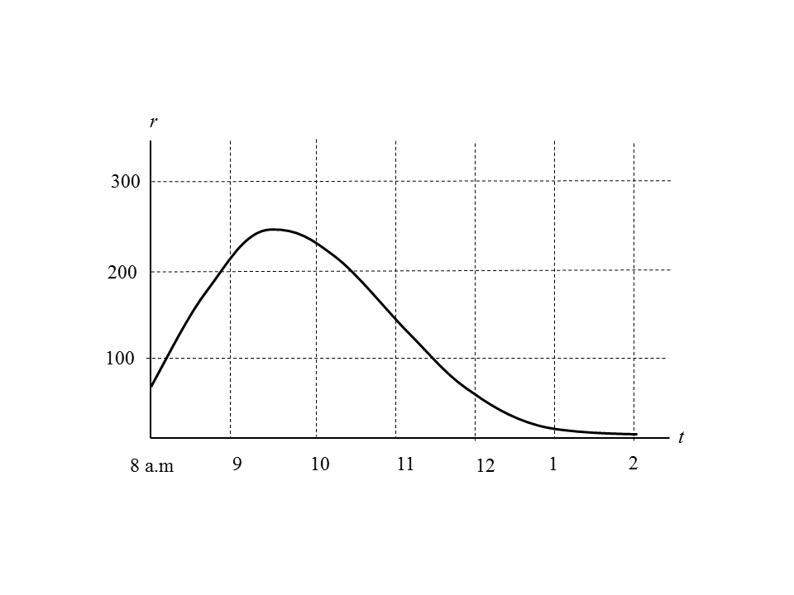The time at which the line disappears.
2. The function *f i*s continuous and takes on the following values:

|  |  |  |  |  |  |  |  |
| --- | --- | --- | --- | --- | --- | --- | --- |
| *x* | 1 | 2 | 3 | 4 | 5 | 6 | 7 |
| *f* (*x*) | 0.14 | 0.21 | 0.28 | 0.36 | 0.44 | 0.54 | 0.50 |

In this problem you will find several estimates for the integral  .

Preliminary work: Get Maple to draw four graphs showing these points.[1] Leave a little room between the graphs to write your answers to the problems. Print it out for use in the rest of the problem.

* 1. Using the first graph you generated, draw and shade the intervals corresponding to a left Riemann sum with three equal subintervals. Then calculate the approximation, writing your answer in the space below the first graph.
  2. On the second graph, draw and shade the intervals corresponding to a right Riemann sum with three equal subintervals. Then calculate the approximation, writing your answer in the space below the second graph.
  3. On the third graph, draw and shade the intervals corresponding to a right Riemann sum with two equal subintervals. Then calculate the approximation, writing your answer in the space below the third graph.
  4. On the fourth graph, draw and shade the intervals corresponding to a midpoint Riemann sum with three equal subintervals. Then calculate the approximation, writing your answer in the space below the fourth graph.

1. Find a definite integral for which  is
   1. a left Riemann sum with 4 subintervals of equal length
   2. A right Riemann sum with 4 subintervals of equal length
2. Using the method (including a carefully labeled diagrams!) we discussed in the handout **Writing a Riemann Sum using -notation**, express the left sum approximation for  using 5, 20, and 50 subintervals.
3. Repeat problem 5, writing right Riemann sum approximations.

1. You will recall that we did this before. If you don’t remember how to do it, check out pointplotexample.mw on p:\data\math\schumacherc\math111.